DATA CLEANING AND VISUALIZATION PROJECT ON TITANIC DATASET

Project Title: Data Cleaning and Visualization on Titanic Dataset

Submitted By: Ankita Kumari

Internship Program: Data Science Internship

Organization: Thiranex.in

Submission Date: June 2026

1. Introduction

Data Science is the process of extracting useful information from raw data. Before performing any analysis, it is important to clean the data and make it suitable for further processing. Data cleaning helps improve data quality by handling missing values, removing duplicate records, and correcting inconsistencies.

In this project, the Titanic Dataset was used to perform data cleaning and visualization. The Titanic dataset is one of the most popular datasets used for learning Data Science and Machine Learning. It contains information about passengers such as age, gender, passenger class, fare, and survival status.

The purpose of this project is to understand how data cleaning techniques and visualization methods can be applied to extract meaningful insights from a real-world dataset.

2. Objective of the Project

The main objectives of this project are:

- To understand the structure of the Titanic Dataset.
- To identify and handle missing values.
- To remove duplicate records.
- To clean the dataset for better analysis.
- To create visualizations for understanding passenger information.
- To identify important trends and patterns related to passenger survival.
- To gain practical experience in Data Science using Python.

3. Dataset Description

The Titanic Dataset contains information about passengers who traveled on the Titanic ship. The dataset includes various attributes that help in understanding passenger demographics and survival outcomes.

Important columns present in the dataset include:

- PassengerId
- Survived
- Pclass
- Name
- Sex
- Age
- SibSp
- Parch
- Ticket
- Fare
- Cabin
- Embarked

The dataset contains both numerical and categorical data, making it suitable for data cleaning and visualization tasks.

4. Data Cleaning Process

Data cleaning is an essential step in Data Science because raw datasets often contain missing values, duplicate records, and irrelevant information.

The following data cleaning techniques were applied in this project:

4.1 Handling Missing Values
The dataset contained missing values in certain columns such as Age and Embarked.

- Missing values in the Age column were replaced using the median value.
- Missing values in the Embarked column were replaced using the most frequent value (mode).

This ensured that no important information was lost while maintaining the quality of the dataset.

4.2 Removing Irrelevant Columns
The Cabin column contained a large number of missing values. Since most entries were unavailable, this column was removed from the dataset.

Removing unnecessary columns helps simplify analysis and improves data quality.

4.3 Removing Duplicate Records
Duplicate records can affect the accuracy of analysis.

The dataset was checked for duplicate entries, and duplicate rows were removed to ensure that each record represented a unique passenger.

4.4 Final Dataset
After performing all cleaning operations, the dataset became more structured, complete, and suitable for visualization and analysis.

5. Data Visualization

Data visualization helps transform raw data into graphical representations that are easy to understand.

Several visualizations were created in this project.

5.1 Survival Count

A count plot was created to compare the number of passengers who survived and those who did not survive.

Observation -

The graph shows that a larger number of passengers did not survive compared to those who survived.

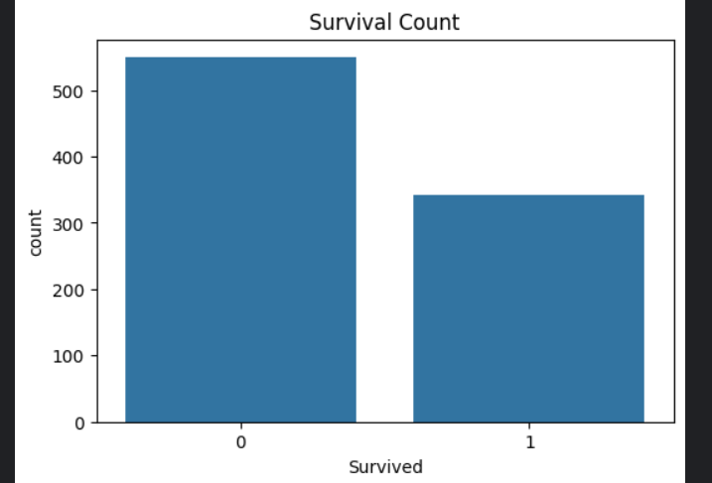

5.2 Passenger Class Distribution

A count plot was used to analyze passenger distribution among different classes.

Observation -

Most passengers belonged to Third Class, followed by First Class and Second Class.

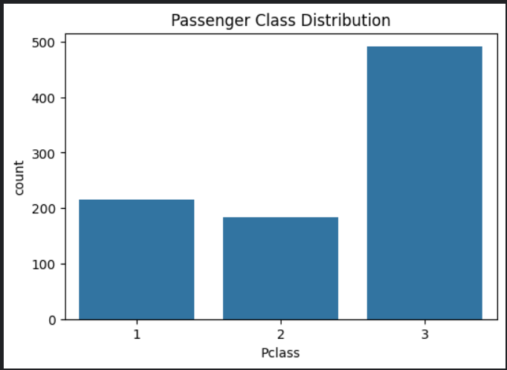

5.3 Age Distribution

A histogram was used to study the age distribution of passengers.

Observation -

The majority of passengers were between 20 and 40 years old.

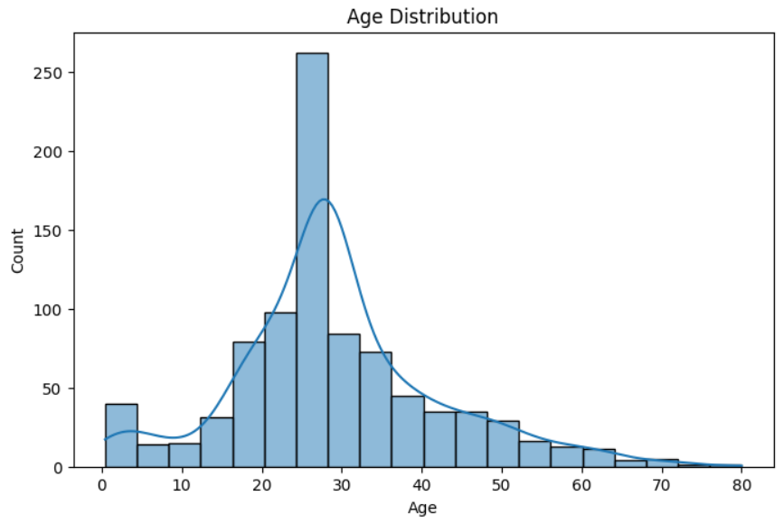

5.4 Gender Distribution

A count plot was created to compare the number of male and female passengers.

Observation -

The dataset contained more male passengers than female passengers.

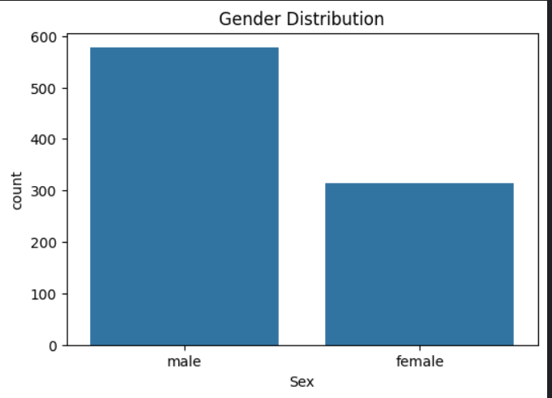

5.5 Survival by Gender

A comparison graph was generated to analyze survival rates based on gender.

Observation -

Female passengers had a significantly higher survival rate than male passengers.

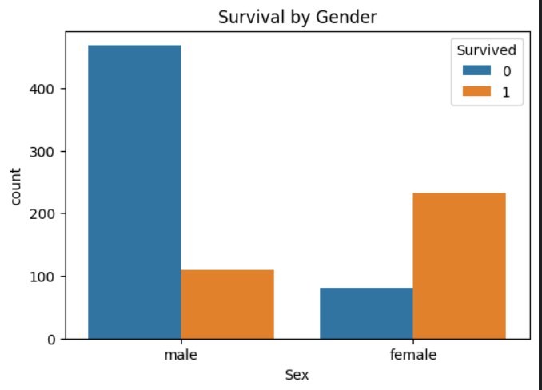

6. Findings and Insights

The analysis of the Titanic Dataset revealed several important insights:

- Female passengers had a greater chance of survival.
- Most passengers belonged to the Third Class category.
- Passenger age was concentrated between 20 and 40 years.
- Passenger class had a strong impact on survival.
- Cleaned data produced more accurate and meaningful results.

These findings demonstrate the importance of data preprocessing and visualization in Data Science.

7. Tools and Technologies Used

The following tools and technologies were used in this project:

- Python
- Pandas
- Matplotlib
- Seaborn
- Kaggle Notebook

These tools helped in data cleaning, analysis, and visualization.

8. Conclusion

The Titanic Dataset was successfully cleaned and analyzed using Python. Missing values were handled, duplicate records were removed, and unnecessary columns were dropped. Various visualizations were created to understand passenger demographics and survival patterns.

The project demonstrated how data cleaning improves data quality and how visualization helps uncover valuable insights from raw data. Through this project, practical knowledge of data preprocessing, exploratory data analysis, and visualization techniques was gained.

Overall, this project provided valuable experience in applying Data Science concepts to a real-world dataset and strengthened understanding of data analysis workflows.

